1) Launch one ec2 using Amazon Linux 2 image and add script in user data to install Apache.

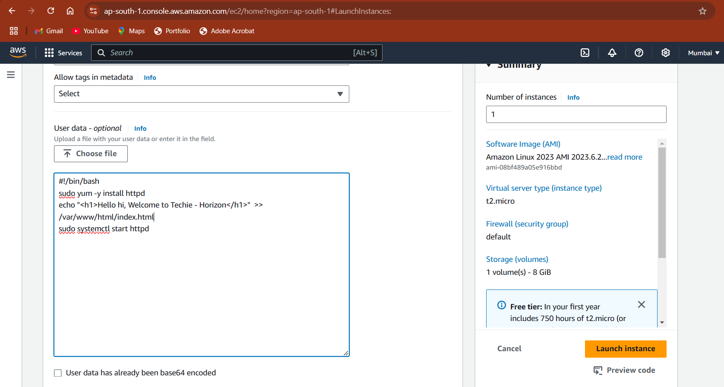

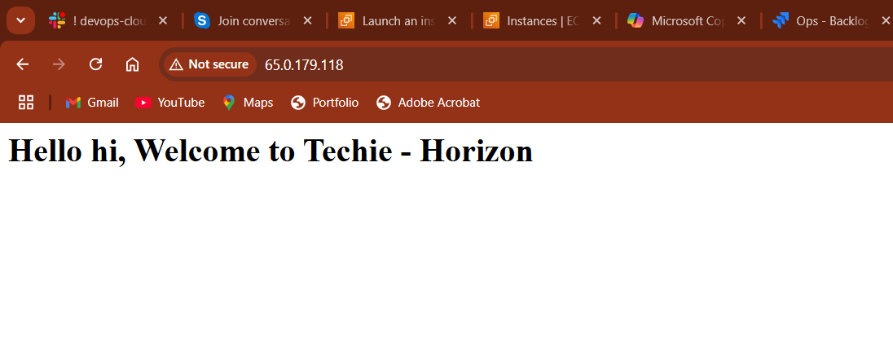

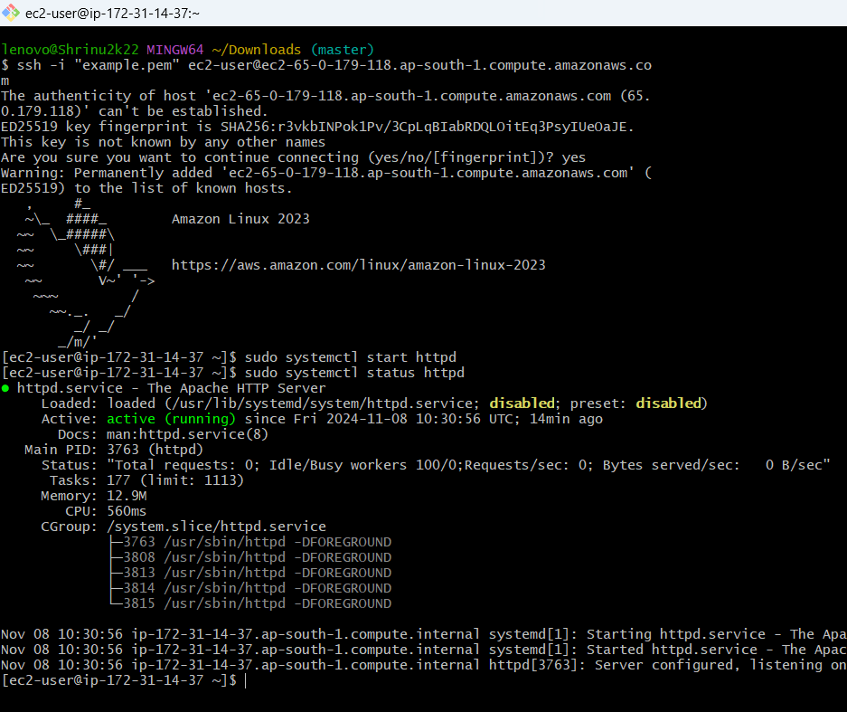

2) Launch one ec2 using Ubuntu image and add script in user data to install Nginx.

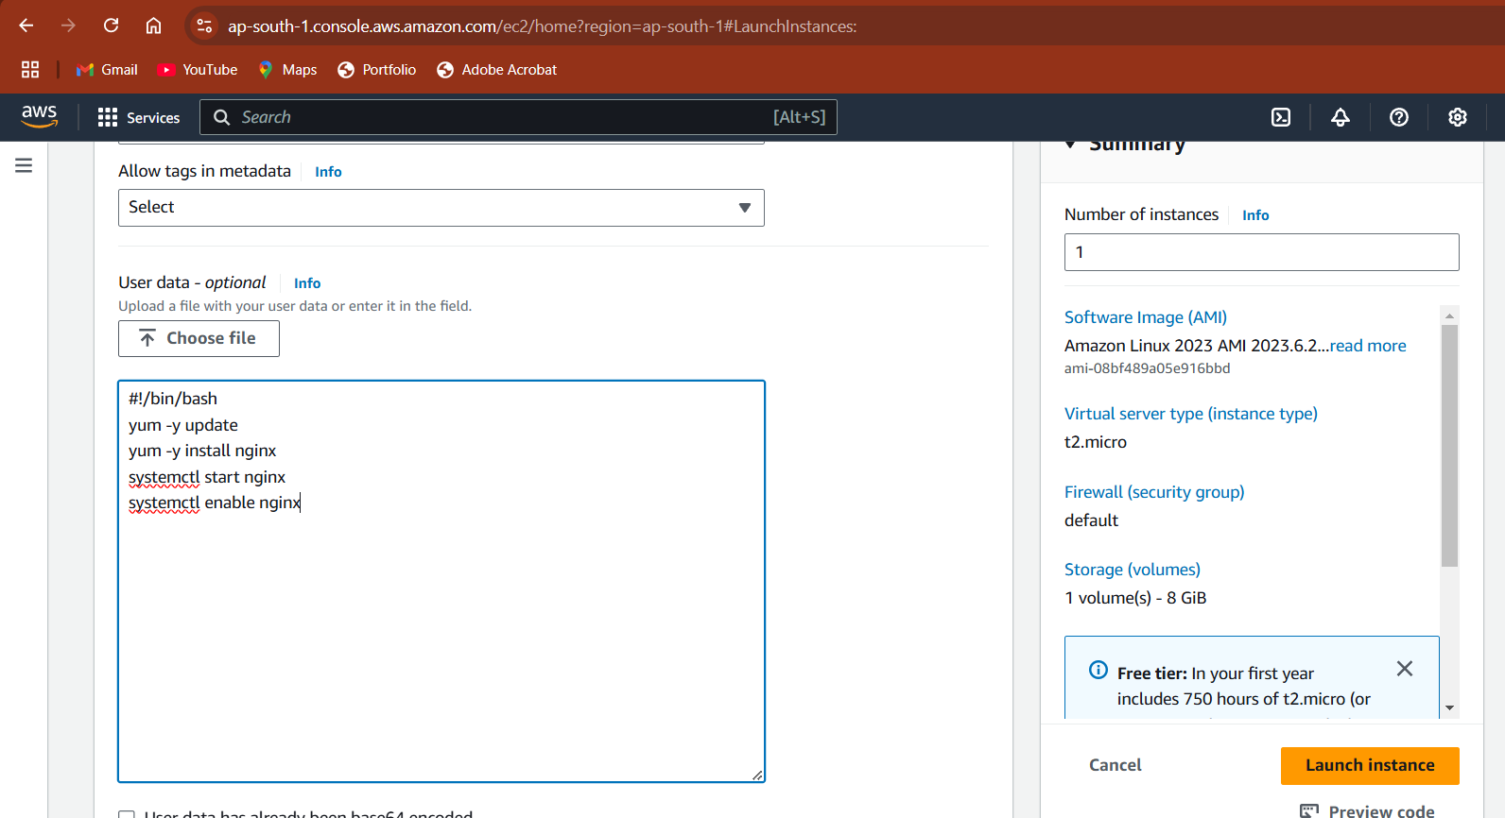

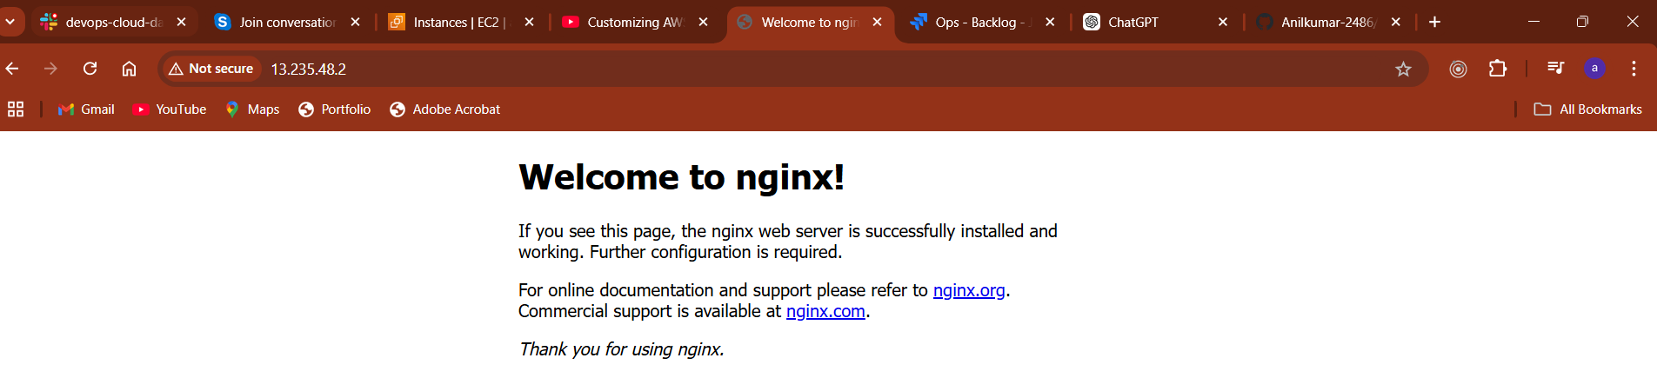

3) Take snapshot of the instane created in Task 1.

If you're using **AWS EC2** to run your Windows Server instance, you can create a snapshot of the instance's volume (EBS volume) through the AWS Management Console.

**Steps to Create a Snapshot in AWS:**

1. **Log in to the AWS Console**:
   * Go to the [AWS Management Console](https://aws.amazon.com/console/) and log in with your credentials.
2. **Navigate to EC2 Dashboard**:
   * In the search bar, type **EC2** and go to the **EC2 Dashboard**.
3. **Select Your Instance**:
   * In the left sidebar, click on **Instances** under **Instances**.
   * Find the instance you created and select it by clicking on its checkbox.
4. **Create a Snapshot**:
   * In the instance details section, find the **Block Devices**.
   * Click on the link for the volume (usually something like /dev/xvda or /dev/sda1).
   * This will take you to the **Volumes** section. Select the volume and click **Actions**.
   * Choose **Create Snapshot**.

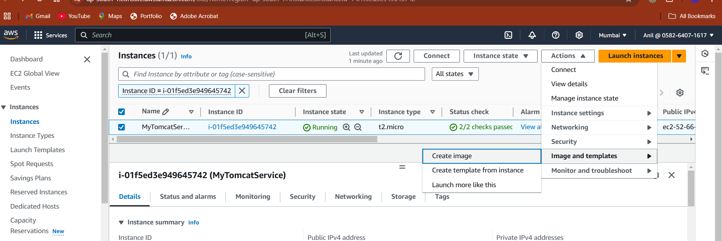

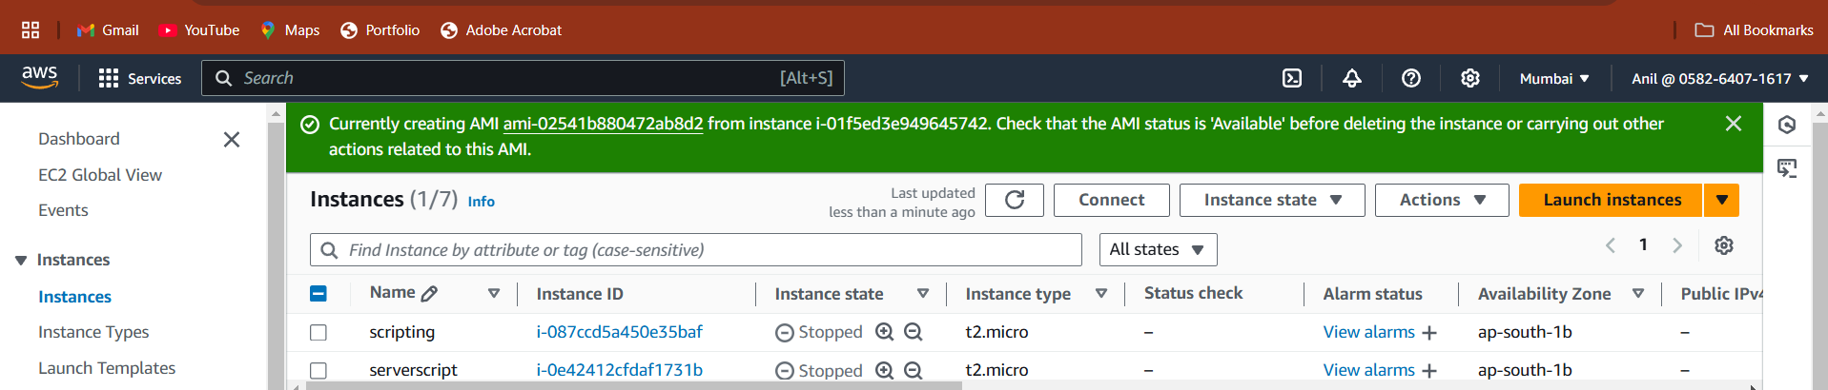

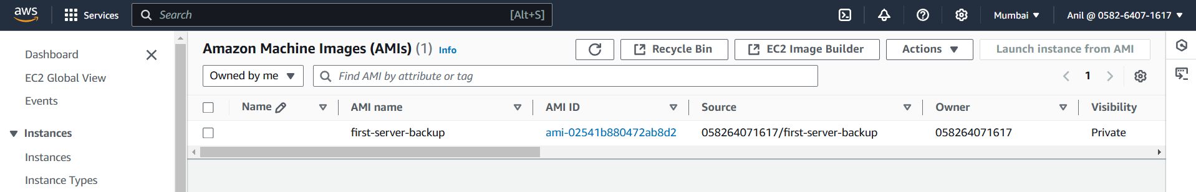

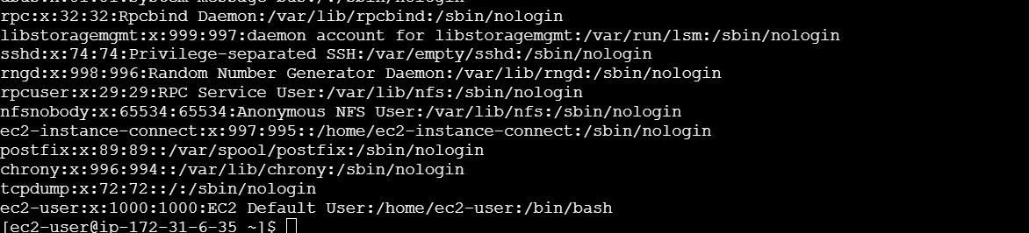

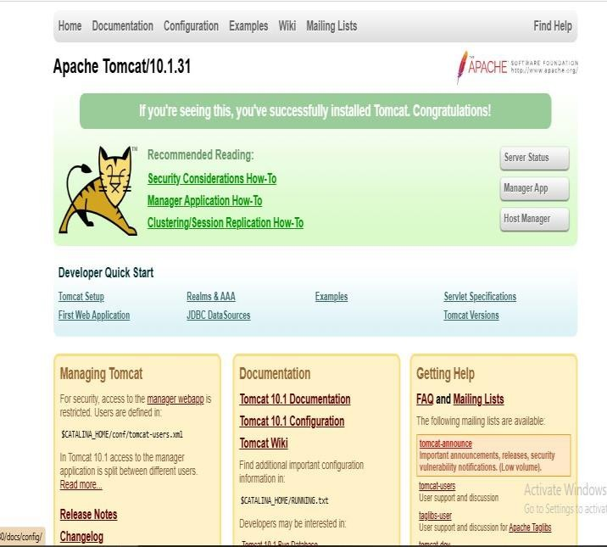4) Launch one windows server and install tomcat in windows

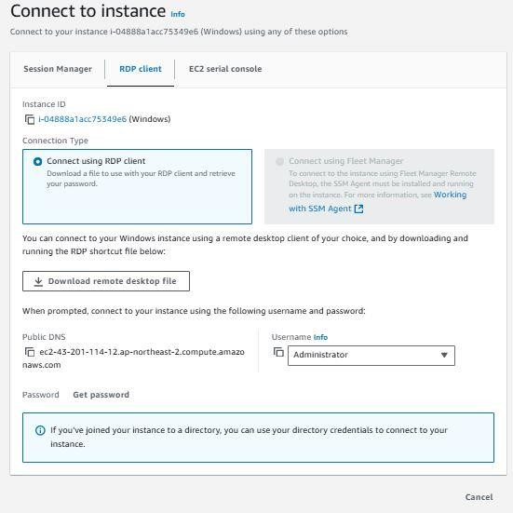

5) Assign password less authentication for ec2 created on Task 2.

When you launch an EC2 instance, you should already be using SSH keys for authentication. By default, the instance won't allow password authentication for SSH logins unless you explicitly change its configuration.

To make sure you have access via SSH key pair, you should already have the SSH key pair (.pem file) you used when creating the instance.

If you need to create or use a new key pair, follow these steps:

* **Generate a new SSH key pair (if you don't have one already)**: If you don't have an existing key pair, you can create one using the following command on your local machine:

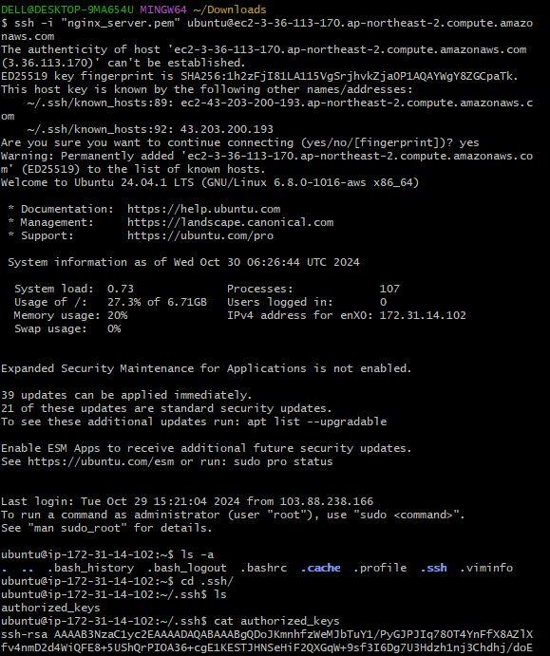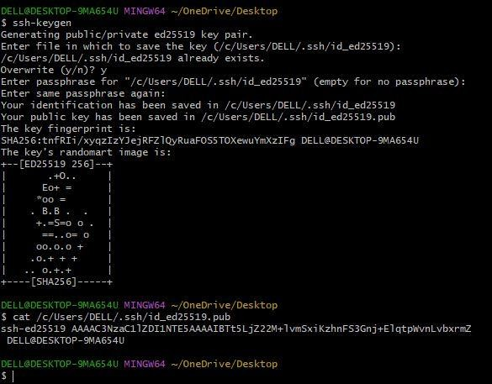

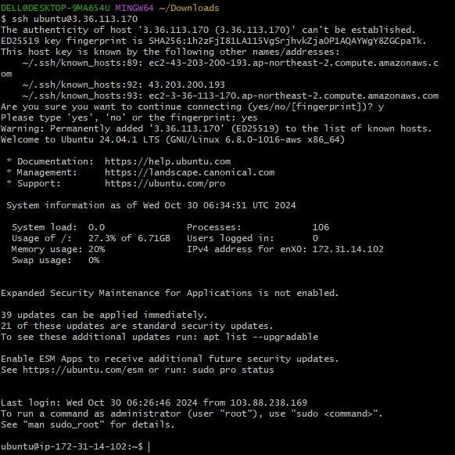6) Launch any ec2 using spot purchasing option.

To launch an EC2 instance using the **Spot Instance** purchasing option, you can use the AWS CLI. Spot Instances allow you to bid for unused EC2 capacity at a lower price than On-Demand instances, but they can be terminated by AWS with little notice if the capacity is needed elsewhere.

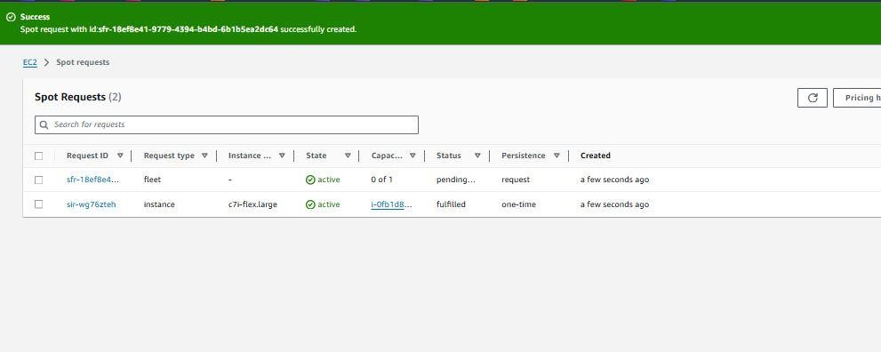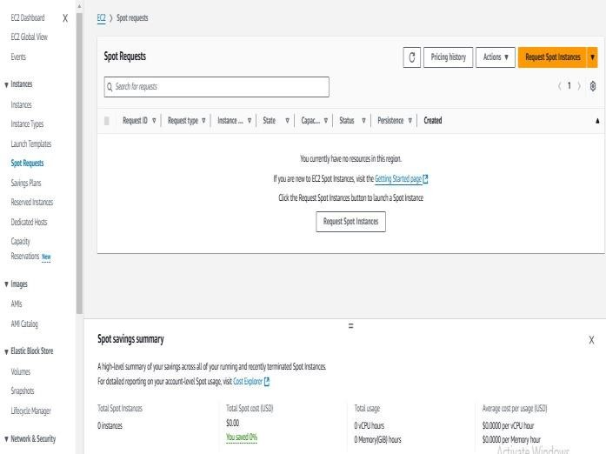7) Enable Termination policy on ec2 created in Task 2.

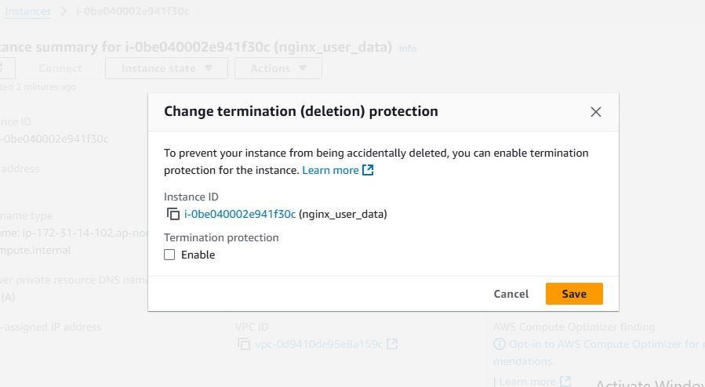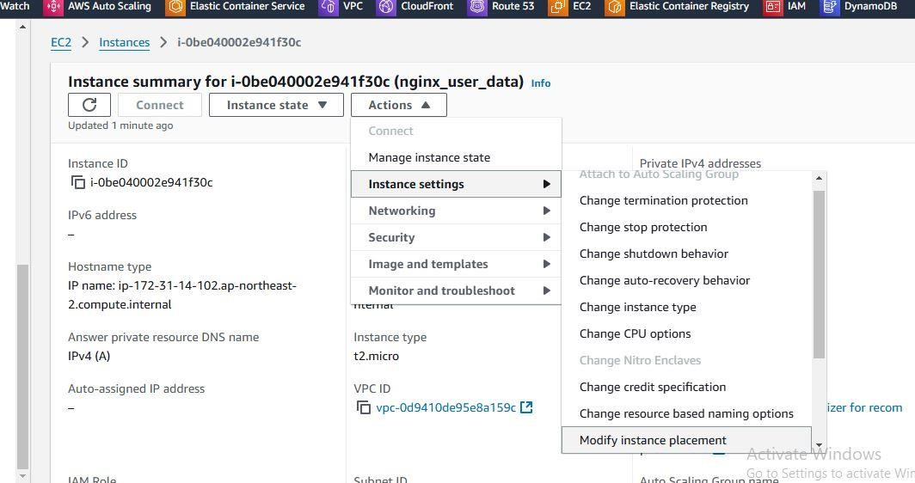

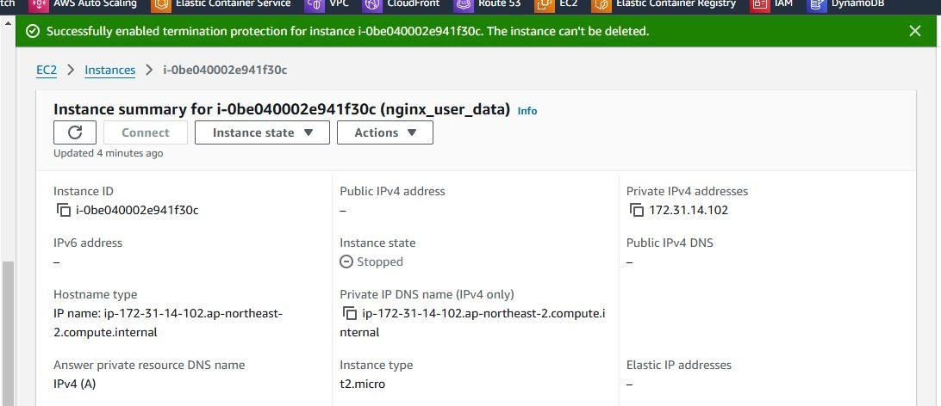

8) Launch one ec2 using Aws CLI.

To launch an EC2 instance using the AWS CLI, you need to follow a few simple steps. Below is a detailed walkthrough of how to launch an EC2 instance using the AWS CLI.

### Prerequisites:

1. **AWS CLI Installed**: Ensure you have AWS CLI installed. You can check if it's installed by running aws --version. If not installed, follow the installation guide for your platform: [Install AWS CLI](https://docs.aws.amazon.com/cli/latest/userguide/install-cliv2.html).
2. **AWS Credentials Configured**: Configure your AWS CLI with your credentials (Access Key, Secret Key, and Region). If you haven't done this yet, use the following command:

aws configure

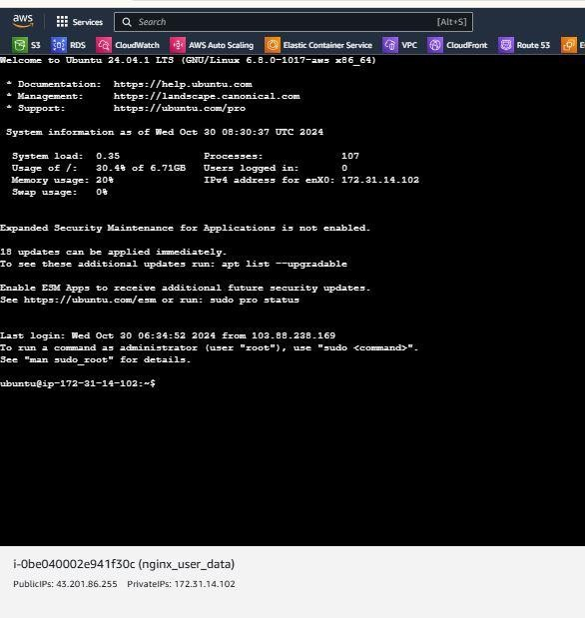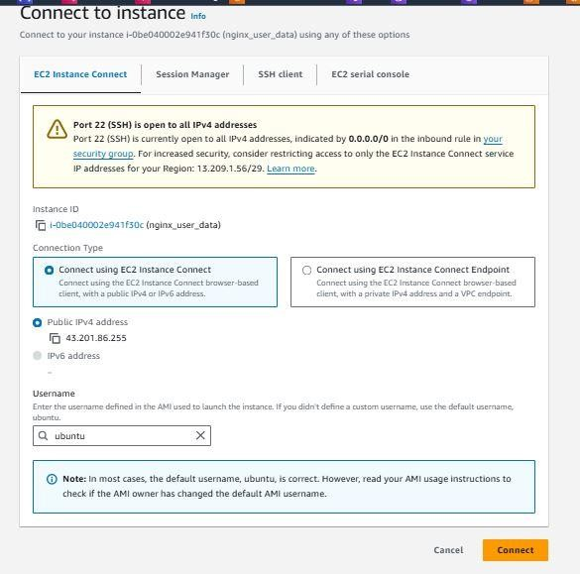

iam unble to create the azure account I facing the issue

